Conditional Logic
# Source: AI Source: Provided by: [Data Path: Persons Table -> ID Column: 1, Name_En Column: Motasem Essam] -> From: [Chatgpt (GPT‑5 Mini)] on [12/9/2025]
Conditional Logic is used to make decisions in your program based on certain conditions.
👉 It answers the question:
“If this happens, what should the program do?”

🔑 Key Idea
# Source: AI Source: Provided by: [Data Path: Persons Table -> ID Column: 1, Name_En Column: Motasem Essam] -> From: [Chatgpt (GPT‑5 Mini)] on [12/9/2025]
Execute different code depending on whether a condition is true or false

🧩 Basic Syntax
# Source: AI Source: Provided by: [Data Path: Persons Table -> ID Column: 1, Name_En Column: Motasem Essam] -> From: [Chatgpt (GPT‑5 Mini)] on [12/9/2025]
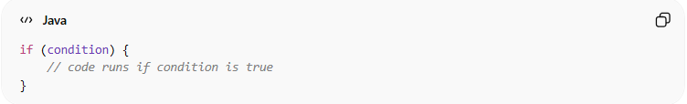
if (condition) {
// code runs if condition is true
}

🧱 Common Forms of Conditional Logic

1️⃣ if Statement
# Source: AI Source: Provided by: [Data Path: Persons Table -> ID Column: 1, Name_En Column: Motasem Essam] -> From: [Chatgpt (GPT‑5 Mini)] on [12/9/2025]
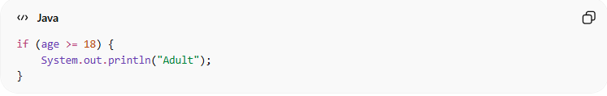
if (age >= 18) {
System.out.println("Adult");
}

2️⃣ if-else Statement
# Source: AI Source: Provided by: [Data Path: Persons Table -> ID Column: 1, Name_En Column: Motasem Essam] -> From: [Chatgpt (GPT‑5 Mini)] on [12/9/2025]
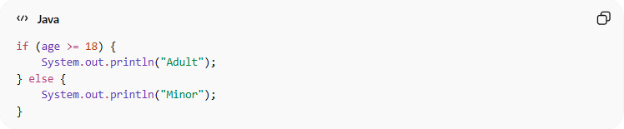
if (age >= 18) {
System.out.println("Adult");
} else {
System.out.println("Minor");
}

3️⃣ if-else if-else
# Source: AI Source: Provided by: [Data Path: Persons Table -> ID Column: 1, Name_En Column: Motasem Essam] -> From: [Chatgpt (GPT‑5 Mini)] on [12/9/2025]
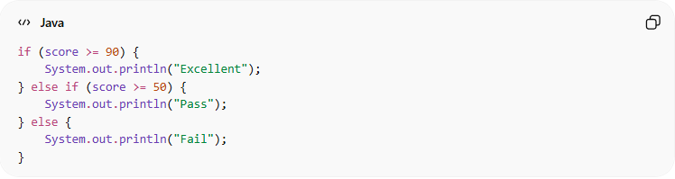
if (score >= 90) {
System.out.println("Excellent");
} else if (score >= 50) {
System.out.println("Pass");
} else {
System.out.println("Fail");
}

4️⃣ switch Statement
# Source: AI Source: Provided by: [Data Path: Persons Table -> ID Column: 1, Name_En Column: Motasem Essam] -> From: [Chatgpt (GPT‑5 Mini)] on [12/9/2025]
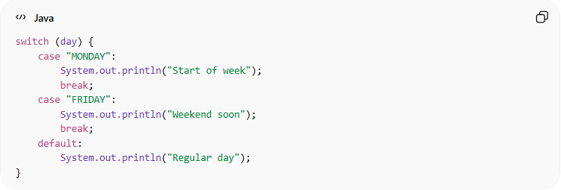
switch (day) {
case "MONDAY":
System.out.println("Start of week");
break;
case "FRIDAY":
System.out.println("Weekend soon");
break;
default:
System.out.println("Regular day");
}

❌ Bad Example (Messy Conditions)
# Source: AI Source: Provided by: [Data Path: Persons Table -> ID Column: 1, Name_En Column: Motasem Essam] -> From: [Chatgpt (GPT‑5 Mini)] on [12/9/2025]
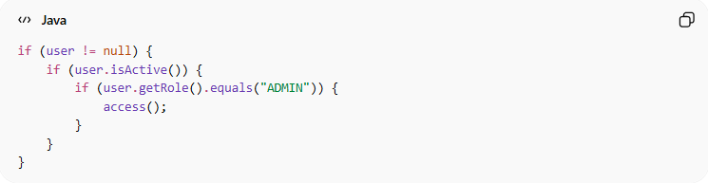
if (user != null) {
if (user.isActive()) {
if (user.getRole().equals("ADMIN")) {
access();
}
}
}
👉 Too much nesting → hard to read

✅ Good Example (Clean Conditions)
# Source: AI Source: Provided by: [Data Path: Persons Table -> ID Column: 1, Name_En Column: Motasem Essam] -> From: [Chatgpt (GPT‑5 Mini)] on [12/9/2025]
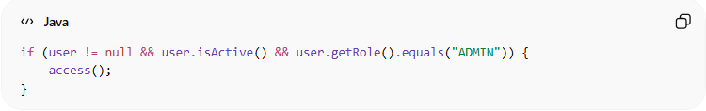
if (user != null && user.isActive() && user.getRole().equals("ADMIN")) {
access();
}
👉 Simple and readable

💡 Best Practices
# Source: AI Source: Provided by: [Data Path: Persons Table -> ID Column: 1, Name_En Column: Motasem Essam] -> From: [Chatgpt (GPT‑5 Mini)] on [12/9/2025]
- Keep conditions simple and clear
- Avoid deep nesting
- Use meaningful variables
- Extract complex logic into functions

🧾 Summary
# Source: AI Source: Provided by: [Data Path: Persons Table -> ID Column: 1, Name_En Column: Motasem Essam] -> From: [Chatgpt (GPT‑5 Mini)] on [12/9/2025]
Conditional logic allows your program to:
- Make decisions
- Control execution flow
- Handle different scenarios

